**LAB 7: Bernoulli Equation and Minor Losses**

Ratthamnoon Prakitpong - 63205165

Hamayun Aziz - 62064167

Arjun Vadehra - 20037164

Section A

Lab Date: March 23rd, 2018

**Summary**

This lab examines Bernoulli equation, which relations the energy of two states in a liquid system. By measuring static head, dynamic head and “head loss” in a simple flow starting from a constant head reservoir, we can compare two states of the flow and prove the Bernoulli equation to be true. We will be doing this in two ways: Venturi flow meter, and Pitot-Static system.

**Procedures**

See Mech 222 Lab manual

**Data and Calculations**

|  |  |  |  |  |  |  |  |  |  |
| --- | --- | --- | --- | --- | --- | --- | --- | --- | --- |
| Setting | Height 1 (mm) | 2 (mm) | 3 (mm) | 4 (mm) | 5 (mm) | 6 (closest to tank) (mm) | Uncertainty (mm) | Tank height (mm) | Uncertainty (mm) |
| Initial (no flow) | 381 | 381 | 381 | 381 | 381 | 381 | 0.5 | 384 | 0.5 |
| 1 | 302 | 302 | 358 | 344 | 372 | 367 | 0.5 | 384 | 0.5 |
| 2 | 224 | 221 | 336 | 303 | 361 | 351 | 0.5 | 384 | 0.5 |
| 3 | 139 | 130 | 315 | 261 | 349 | 335 | 1.5 | 384 | 0.5 |

*Table 1: Raw readings from manometer*

|  |  |  |  |  |  |  |  |
| --- | --- | --- | --- | --- | --- | --- | --- |
|  | 1 (mm) | 2 (mm) | 3 (mm) | 4 (mm) | 5 (mm) | 6 (closest to tank) (mm) | Uncertainty (mm) |
| Position from tank (mm) | 650 | 642.5 | 510 | 395 | 215 | 215 | 5 |

*Table 2: Position of manometer from tank*

|  |  |  |
| --- | --- | --- |
| Constants |  |  |
| Water density | 1000 | kg/m^3 |
| Pipe ID | 21 | mm |
| Throat ID | 11 | mm |
| Gravity | 9.81 | m/s^2 |
| Center line height | 0.385 | m |

*Table 3: Relevant constants*

|  |  |  |  |  |  |
| --- | --- | --- | --- | --- | --- |
| Setting | Manometer 5 (m) | Manometer 6 (m) | Velocity at manometer 6 (m/s) | Manometer uncertainty (m) | Uncertainty (m/s) |
| Initial (no flow) | 0.381 | 0.381 | 0.000 | 0.0005 | #DIV/0! |
| 1 | 0.372 | 0.367 | 0.313 | 0.0005 | 0.0221 |
| 2 | 0.361 | 0.351 | 0.443 | 0.0005 | 0.0157 |
| 3 | 0.349 | 0.335 | 0.524 | 0.0015 | 0.0397 |

*Table 4: Average velocity at each valve settings, calculated using Pitot-Static system*

|  |  |  |  |  |  |
| --- | --- | --- | --- | --- | --- |
| Setting | Manometer 4 (m) | Manometer 6 (m) | Velocity at manometer 6 (m/s) | Manometer uncertainty (m) | Uncertainty (m/s) |
| Initial (no flow) | 0.381 | 0.381 | 0.000 | 0.0005 | #DIV/0! |
| 1 | 0.344 | 0.367 | 0.264 | 0.0005 | 0.00406 |
| 2 | 0.303 | 0.351 | 0.381 | 0.0005 | 0.00281 |
| 3 | 0.261 | 0.335 | 0.473 | 0.0015 | 0.00679 |

*Table 5: Average velocity at each valve settings, calculated using Venturi flow meter*

|  |  |  |
| --- | --- | --- |
| Case 1 | Pitot-Static | Venturi |
| Velocity (m/s) | 0.313 | 0.264 |
| Uncertainty (m/s) | 0.0221 | 0.00406 |
| Min/max value (m/s) | 0.291 | 0.268 |

*Table 6: Case #1 comparison of Pitot-Static and Venturi*

|  |  |  |  |  |  |  |
| --- | --- | --- | --- | --- | --- | --- |
|  | 1 | 2 | 3 | 4 | 5 | 6 (closest to tank) |
| Position from tank (m) | 0.65 | 0.6425 | 0.51 | 0.395 | 0.215 | 0.215 |
| Manometer height (m) | 0.302 | 0.302 | 0.358 | 0.344 | 0.372 | 0.367 |
| Total head (m) | 0.3056 | 0.3056 | 0.3616 | 0.3476 | 0.3756 | 0.3706 |

*Table 7: Total head calculation, according to data from Venturi flow meter*

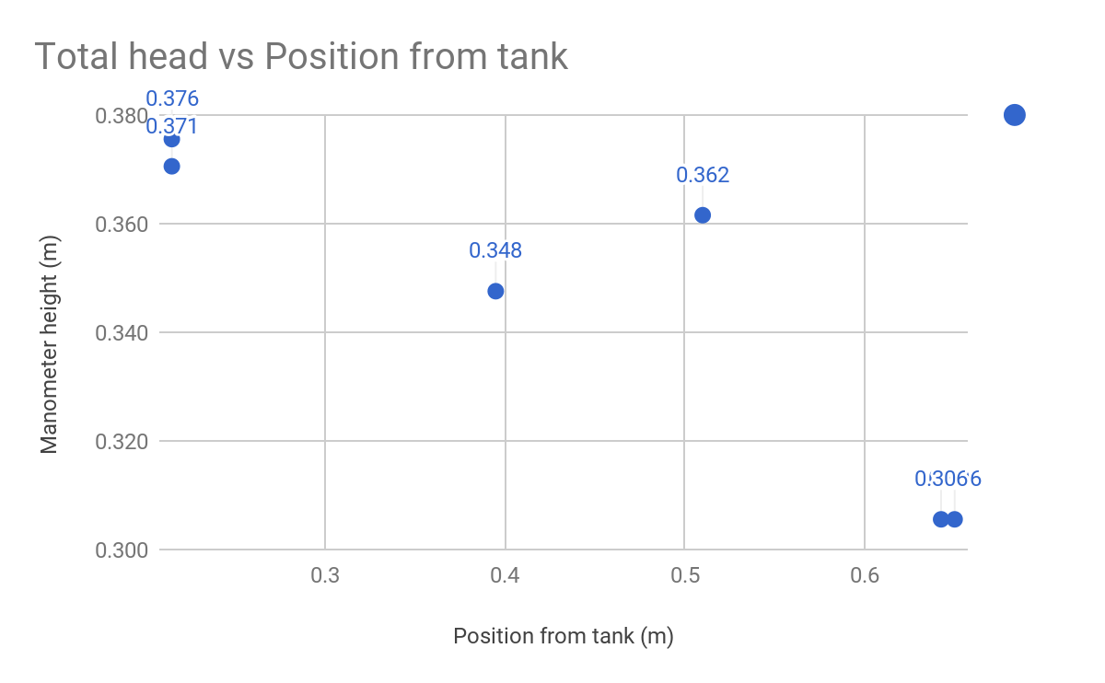

*Figure 1: Total head vs Position from tank, according to data from Venturi flow meter*

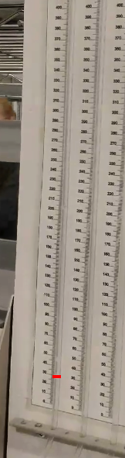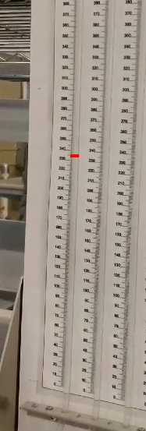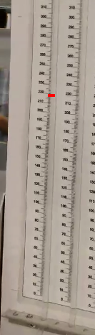

*Figure 2: Observation of manometer height change; notice a small overshoot immediately after valve change*

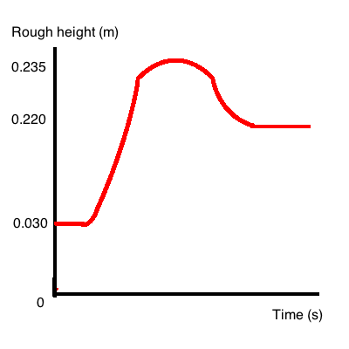

*Figure 3: Rough plot of the manometer height over time for sudden flow change experiment*

**Discussion/Required Content**

**1.**

**For the three valve positions, calculate the average velocity of flow using the Pitot-Static**

**system (9) and the Venturi (7). (Show a sample calculation for each velocity, for valve position 1 only.)**

For Pitot-Static, please refer to Table 4 and Appendix A. For Venturi, please refer to Table 5 and Appendix A.

**2.**

**Estimate the errors in the velocity measurements for the two locations and three valve positions based on your estimates of water height uncertainty. (Use the error analysis methods introduced in the MECH 221 Statistics classes, also found in Appendix A of Lab 1; show sample calculations). Do your velocity measurements agree within experimental error? If not, suggest possible reasons why.**

For Pitot-Static, please refer to Table 4 and Appendix B. For Venturi, please refer to Table 5 and Appendix B.

Even with the experimental error accounted, the velocities did not match. For example, in the first case comparison in Table 6, the values still has .073 m/s difference with uncertainty accounted.

This can largely be attributed to losses. The Venturi’s manometer (#4) is farther than the Pitot-Static’s manometer (#5) (.180 m difference), resulting in more loss at that measurement. This is reflected in the calculated velocity of the Venturi experiments being less than Pitot-Static. Another issue can be in measurement error, although it has already been accounted for in the uncertainty measurements.

**3.**

**Calculate the total head at all locations (use the tube centreline as a reference elevation). (Show a sample calculation for the total head for the static tube and Pitot tube locations using valve position 1.) If there were observed differences in the velocity calculations in Question 1, state which velocity you use and why.**

Assuming velocity stays constant during the whole travel, the calculations and plot of total head of setting #1 are shown in Table 7 and Fig 1, respectively. We picked Venturi due to its lower uncertainty value. You can find sample calculation for manometer #2 (Pitot Static tube) in Appendix C.

Note that there is a bump at the third manometer. This is due to the pressure tap of Venturi flow meter. Have this been accounted for, the slope would look more linear than currently.

**4.**

**Compare the values obtained for total head to the elevation at the reservoir. Can you observe a change in the total head along the length of the tube? (Briefly explain your findings.)**

Total head decreases as distance from reservoir increases, comparing 0.3706 m at the closest manometer to 0.3056 m at the farthest manometer (Table 7). This is due to losses that are proportional to flow distance, such as friction, as the water flows along the tube. Total head is always less than the reservoir because no extra energy was added to generate flow, while some energy was lost to friction.

**5. Plot total head versus the approximate pipe length for various valve settings. What is the head loss at the exit?**

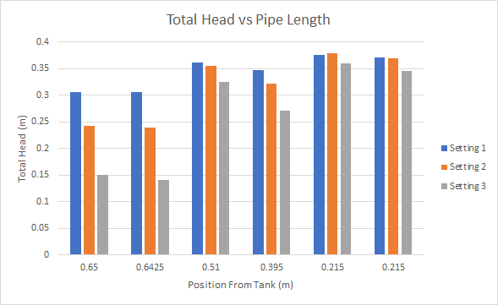

**6. Consider Step 5 of the Procedure where the discharge valve is closed abruptly.**

1. **What do you observe in the tube adjacent to this valve? Include a rough sketch of the transient pressure measured by the manometer tube as a function of time as you shut the valve.**In one of the tubes, the water abruptly shoots up when the valve is changed, then over time comes to an equilibrium position. Refer to Figure 2 & 3 for observation and rough graph sketch. Due to poor video quality, the only observable tube was the one that did not shoot up as far.
2. **What is the approximate pressure difference from well before the valve is closed (with the water running steadily) to well after the valve is closed (when flow has completely stopped)? How does this pressure difference compare to the maximum transient pressure difference you observed when the valve was closed abruptly?**Approximate pressure difference is:  
   Pflow = ρghflow= 1000(9.81).220 Pa = 2158.2 Pa  
   ΔP = ρg(hflow - hno flow) = 1000(9.81)(.220 - .030) Pa = 1863.9 Pa  
   Maximum transient pressure = ρghmax = 1000(9.81).235 Pa = 2305.35 Pa

**7.**

**Consider a large-scale application of this same phenomena: large pipes called**

**“penstocks” bring water from a hydraulic dam to hydraulic turbines to generate**

**electricity. Consider a dam for which the water level at the dam is 300 m above the hydraulic turbines and the average speed of flow at the turbines is 45 m/s. Calculate the change in the static pressure at the penstocks when the water flow is stopped. Based on your findings in Part 6 above, what would you suggest a safe design pressure would be**

**for the structural design of the penstocks in order to account for transient pressure changes?**

According to the observations from part 6, we have found that 2061.6 kPa is the safe pressure accounting for transient maximum pressure. Please refer to Appendix D for calculation.

**Appendixes**

**Appendix A: Sample calculations**

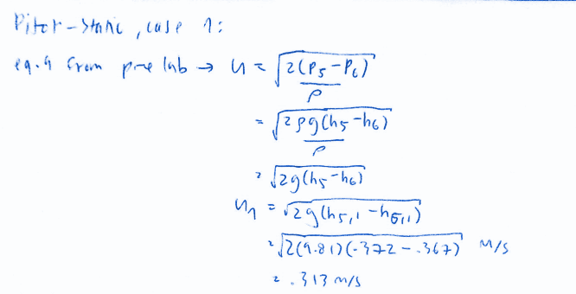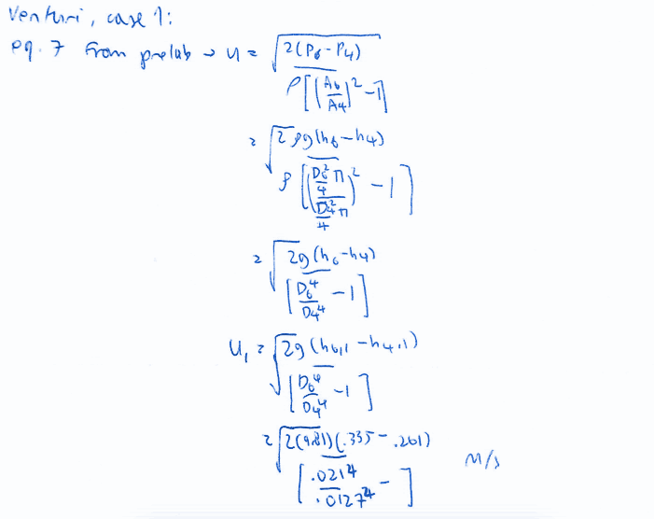

**Appendix B: Uncertainty equation derivation**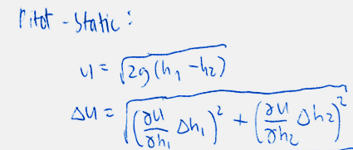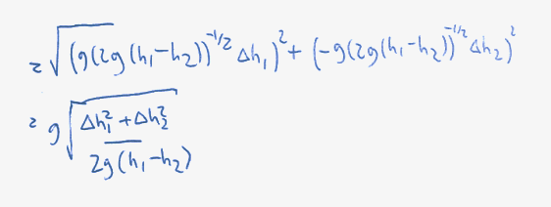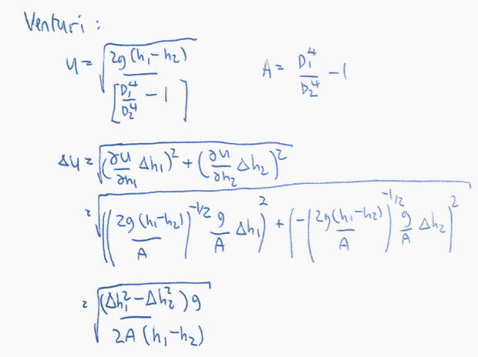

**Appendix C: Sample Calculation**

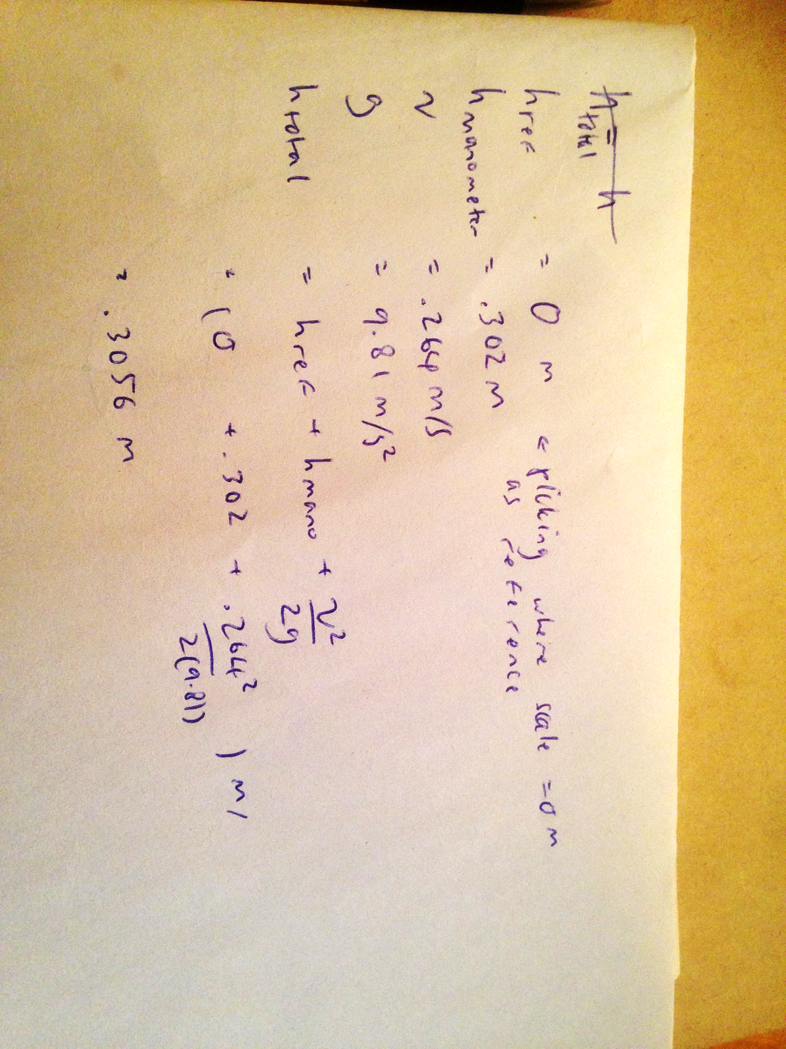

**Appendix D: Sample Calculation**

**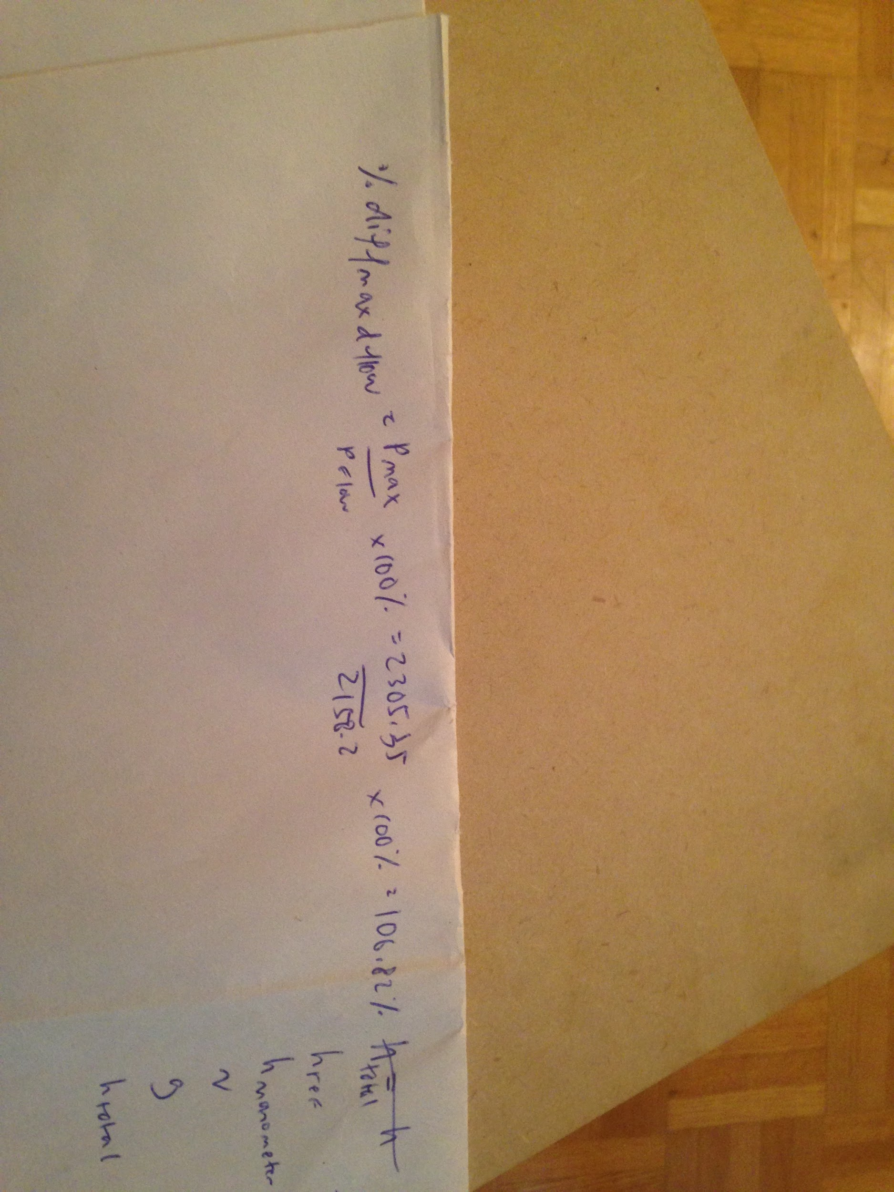***Note that Pmax and Pflow are from Q6 calculations.*

